James Keller – GES408 – Week 4 Lab Activity

Formulate an appropriate null and alternative hypotheses for our comparison. (2 points)
H₀ – The mean size of leaves does not depend on location on the tree
H_{A} – Leaves closer to the outside of the tree will be larger on average than leaves near the inside of the tree.
Use a paired t-test to analyze the data. Report the p-value and interpret the results of your test, both in terms of accepting or rejecting your null hypothesis, and in terms of what this may mean ecologically. (2 points)
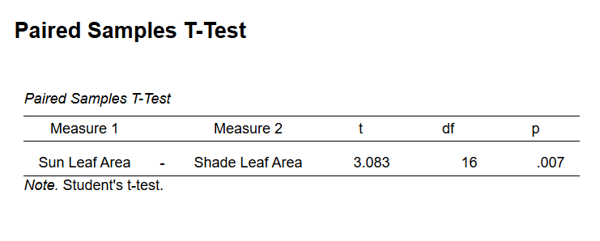
Our p-value is 0.007 which means we reject our null hypothesis with an alpha of 0.05. This suggests that the mean size of leaves does change based on location on the tree. This could mean that trees on the outside of the tree that receive more sun are larger on average to capture more sunlight.

Create a boxplot(s) comparing our two paired measurements, and give a brief description (1-2 sentences). (2 points)
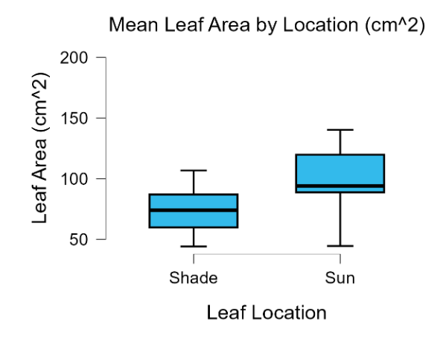
Our boxplot shows that the IQRs are different for each treatment but are close. Leaves that received full sun also appear to have a wider range of areas. However, there is a clear difference in the average sizes leaves based on their locations on the tree.

Why is a paired design more powerful in some ecological contexts? (1 point)
A paired design is more powerful in some ecological contexts because it could help to minimize variation because we are getting samples from the same trees which needs to be incorporated into the statistic testing. We are testing within-individual variation not between individual variations so samples are by definition related and not independent.

